**AIDS Lab**

**EXPERIMENT NO. 2**

**Aim**: To build a Cognitive text-based application to understand context for a customer service application/Insurance/Healthcare Application/Smarter Cities/Government etc.

**Theory**:

Dialog Flow is a natural language understanding platform used to design and integrate a conversational user interface into mobile apps, web applications, devices, bots, interactive voice response systems and related uses. A chatbot or chatterbot is a software application used to conduct an on-line chat conversation via text or text-to-speech, in lieu of providing direct contact with a live human agent. We will be using Dialog Flow to build the chatbot.

**Code and Output**:

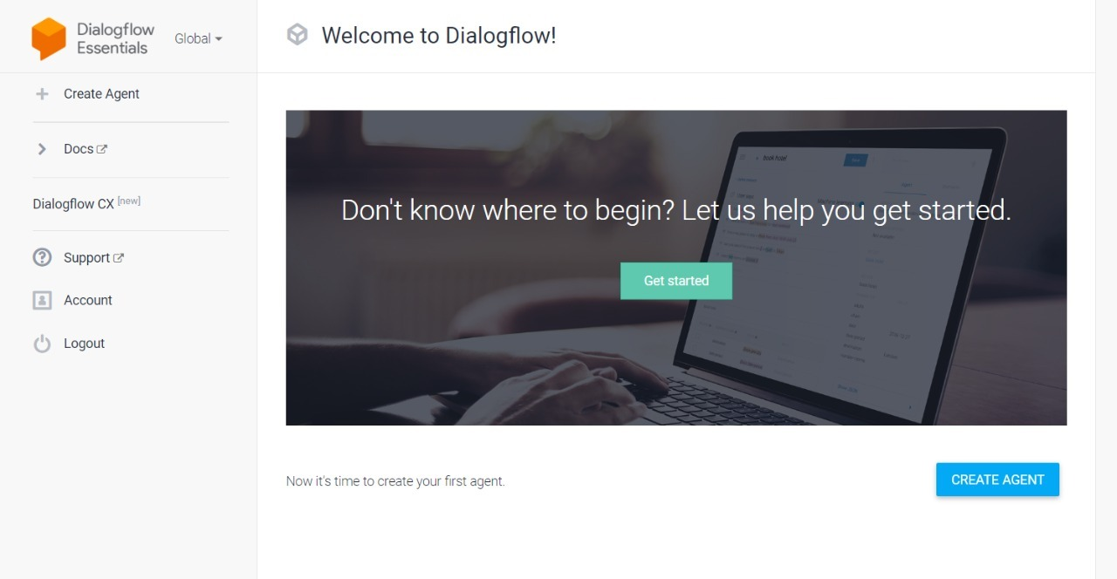

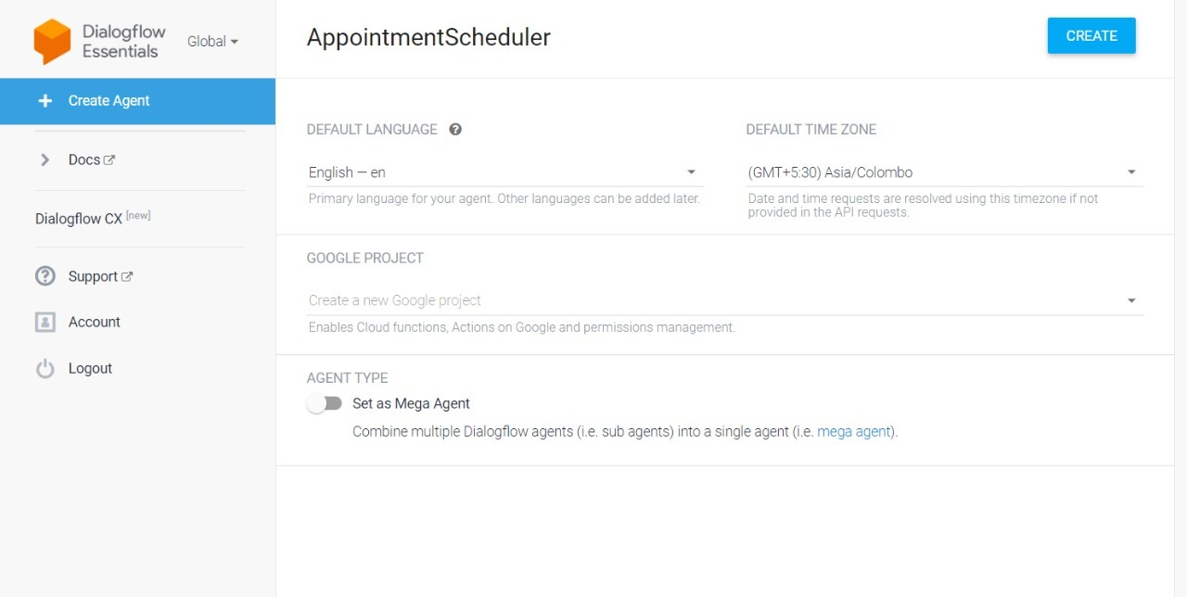

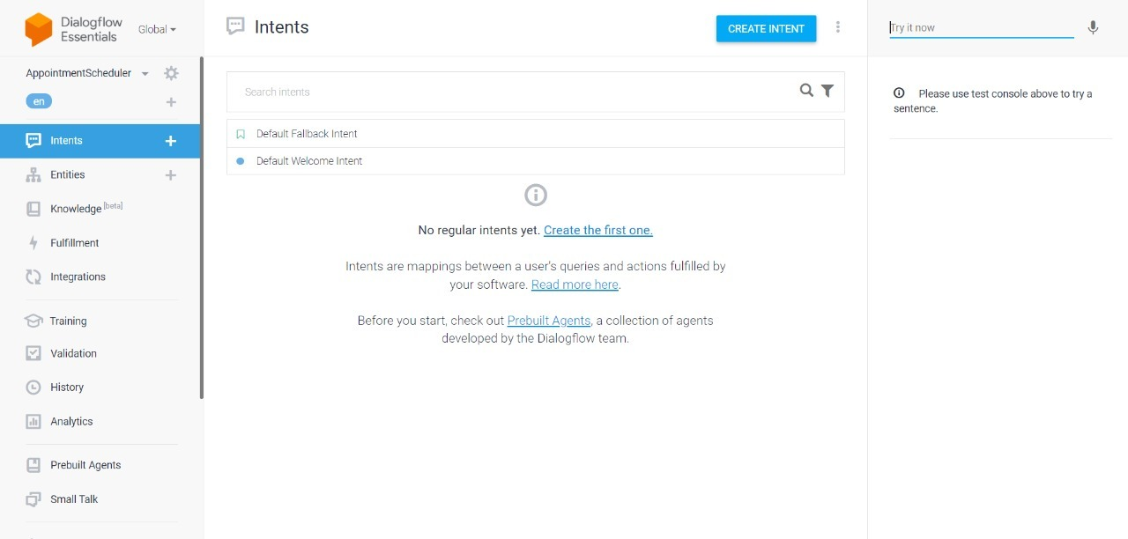

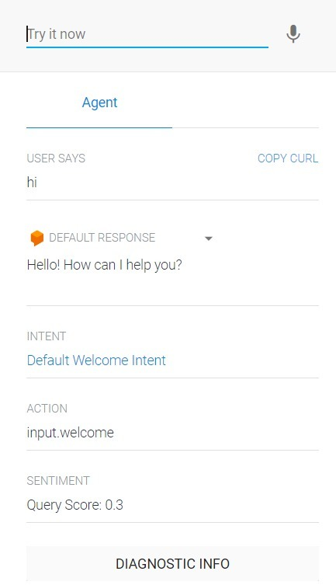

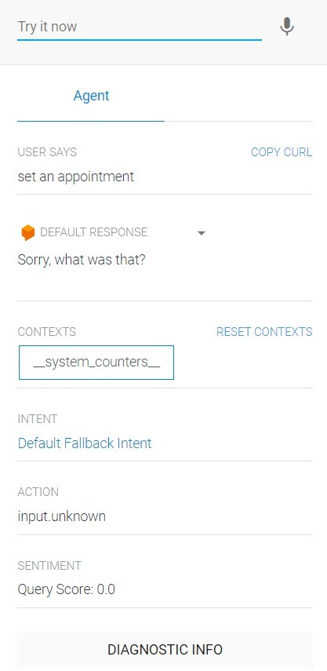

Above are the Default intents and Default fallback intent given by Dialogflow. Now give name to intent and click training phrases.

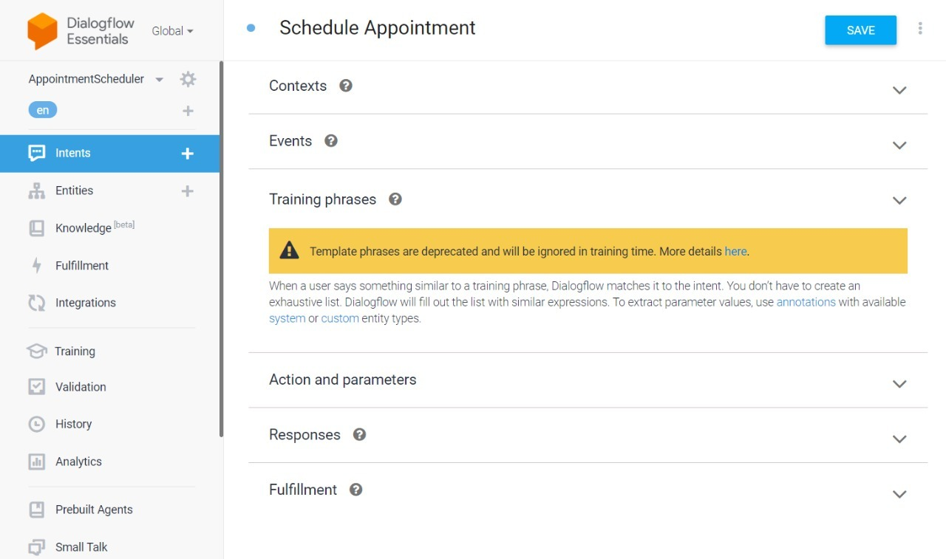

Click add training phrases.

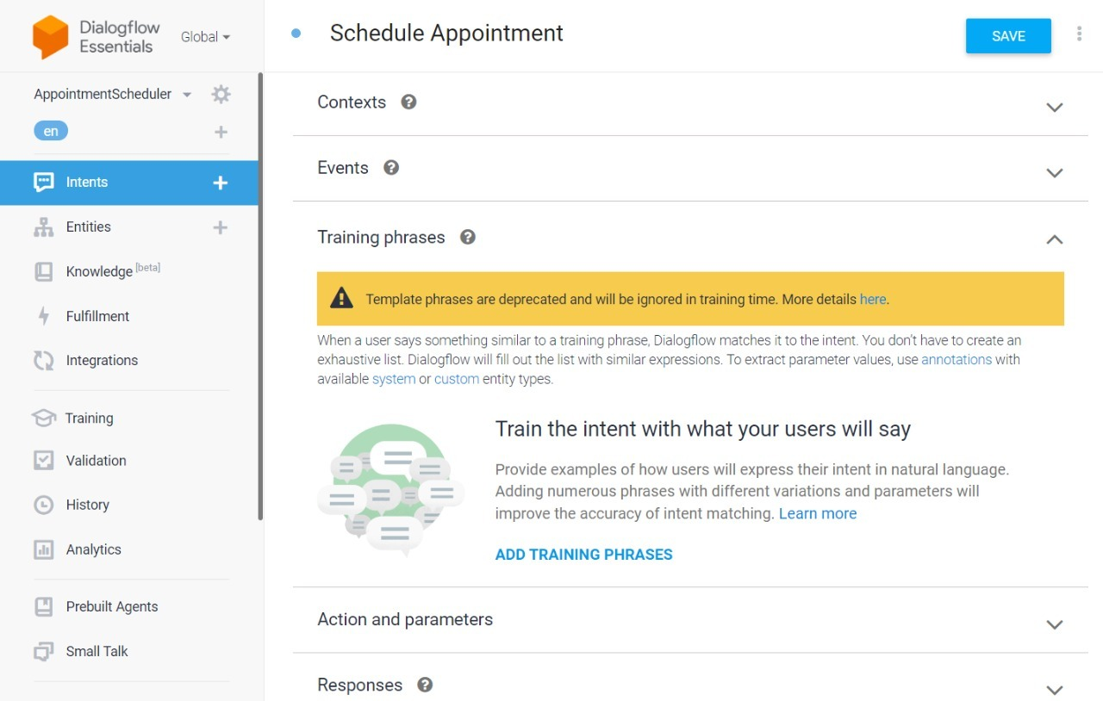

Add these phrases and it automatically detects date time.

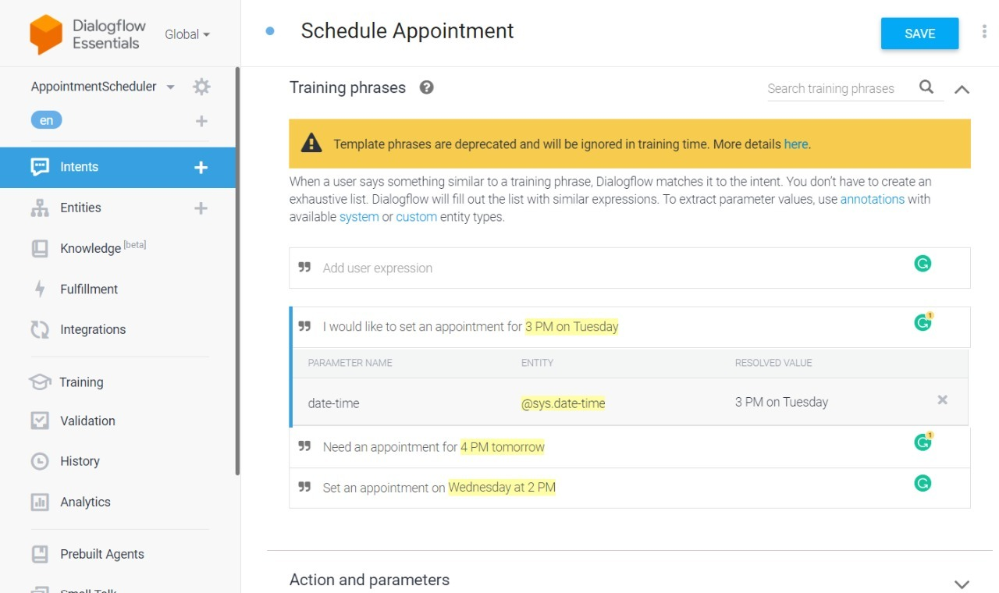

Click on responses and Add a response.

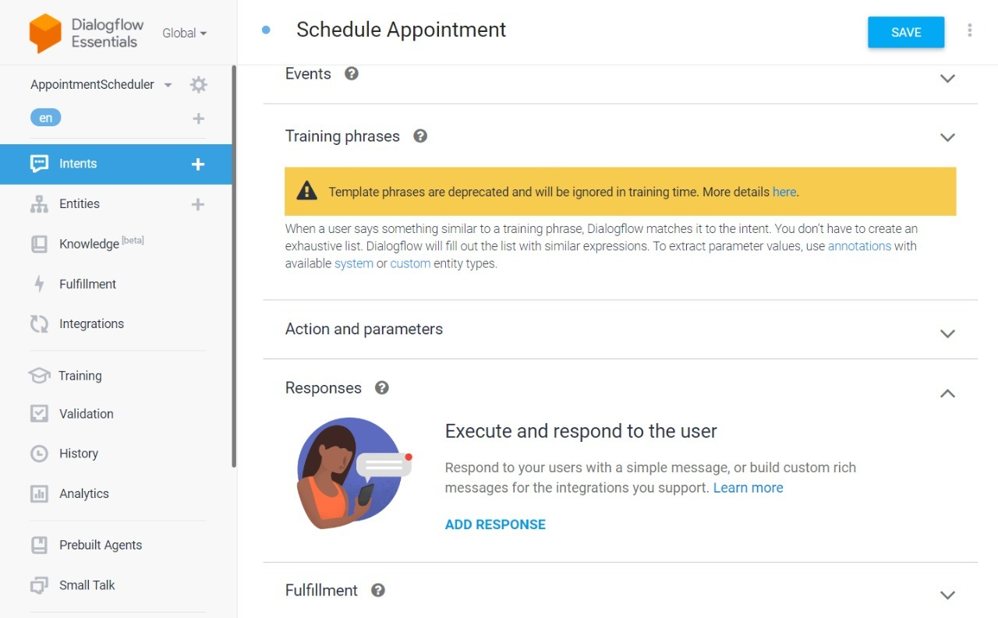

Add this response. Dollar($) sign here helps you access the entity values. After that click Save.

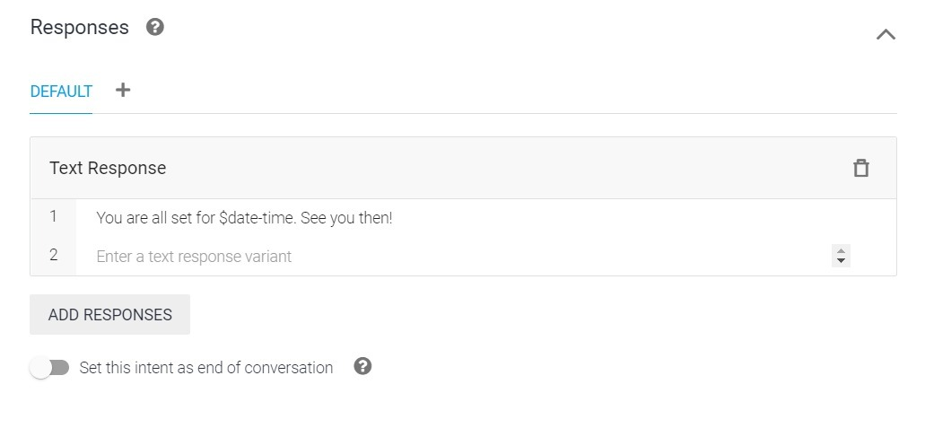

Test agent with query: Set an appointment for 4 PM on Thursday.

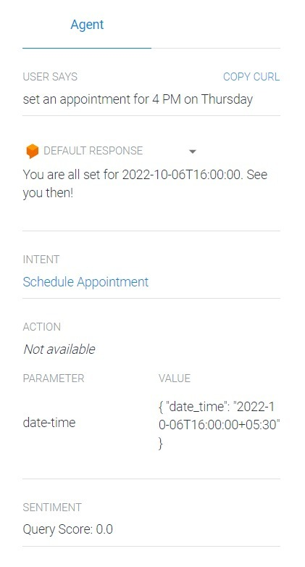

For queries like: Set an appointment, where date time is not specified we have to handle this by asking the user for the same. Click now on Actions and Parameters.

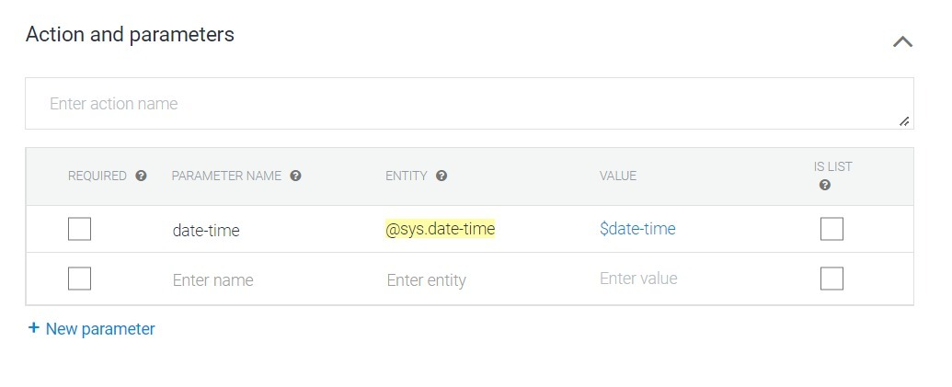

Select date-time as required

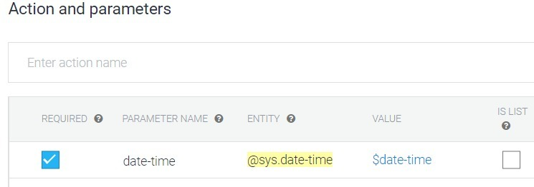

Add your own prompt query and click on Save.

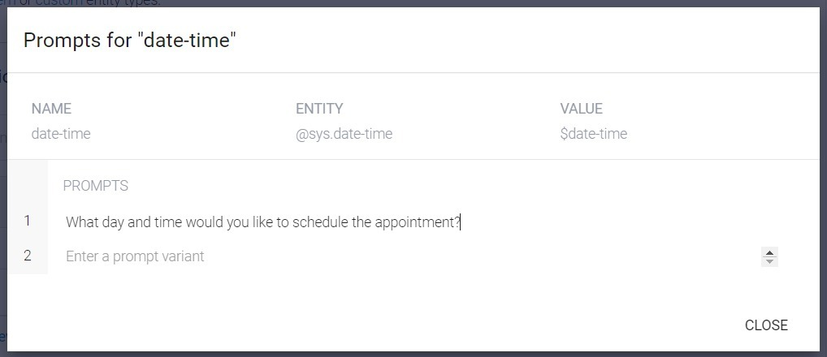

Test the client.

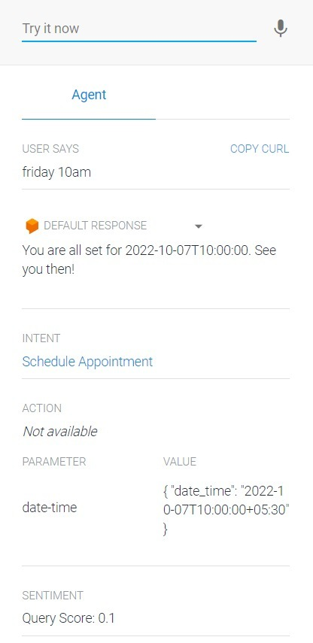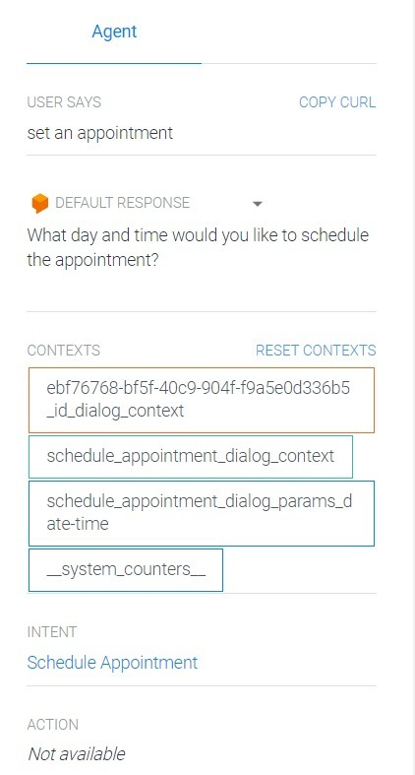

To use the chatbot in your web apps Select Integrations from the left menu and Click on Web Demo under the Text based section.

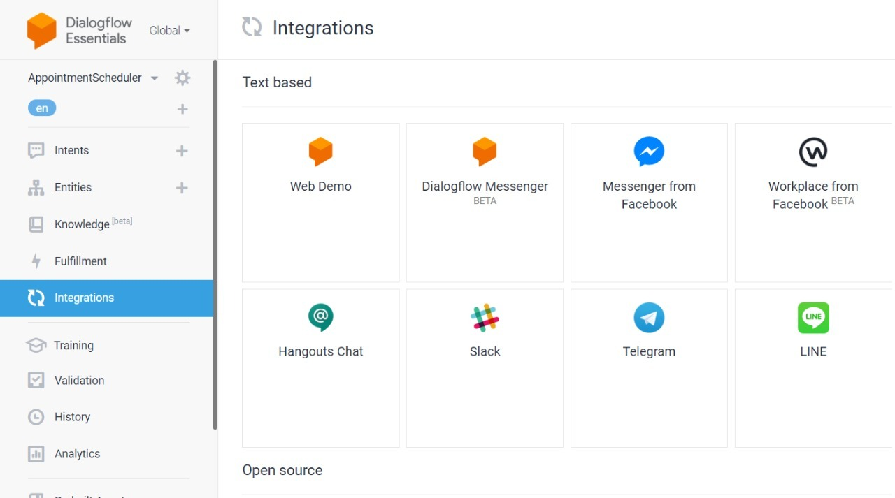

Click on Enable and click on the Link.

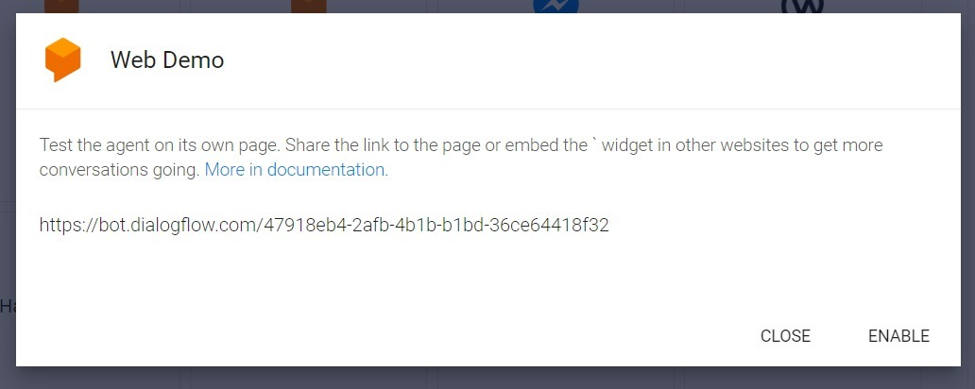

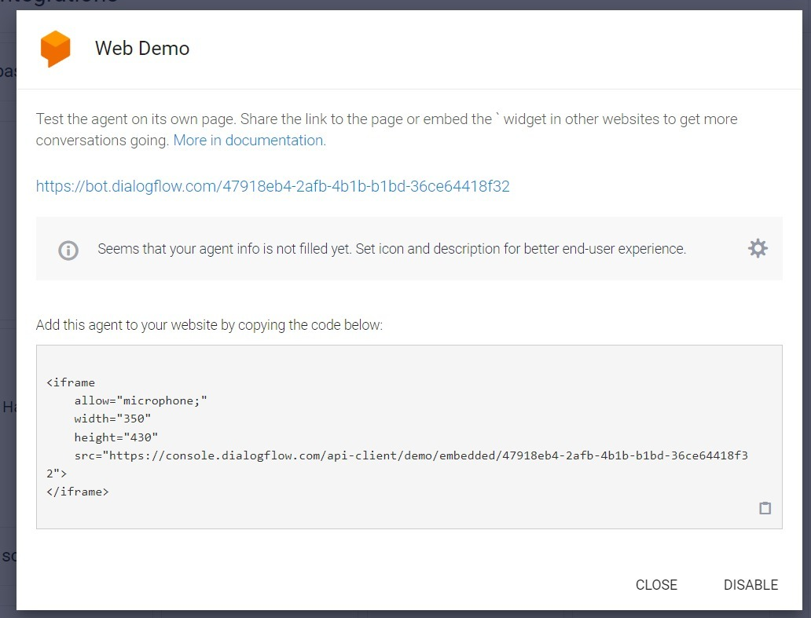

Final chatbot using Dialog Flow is ready.

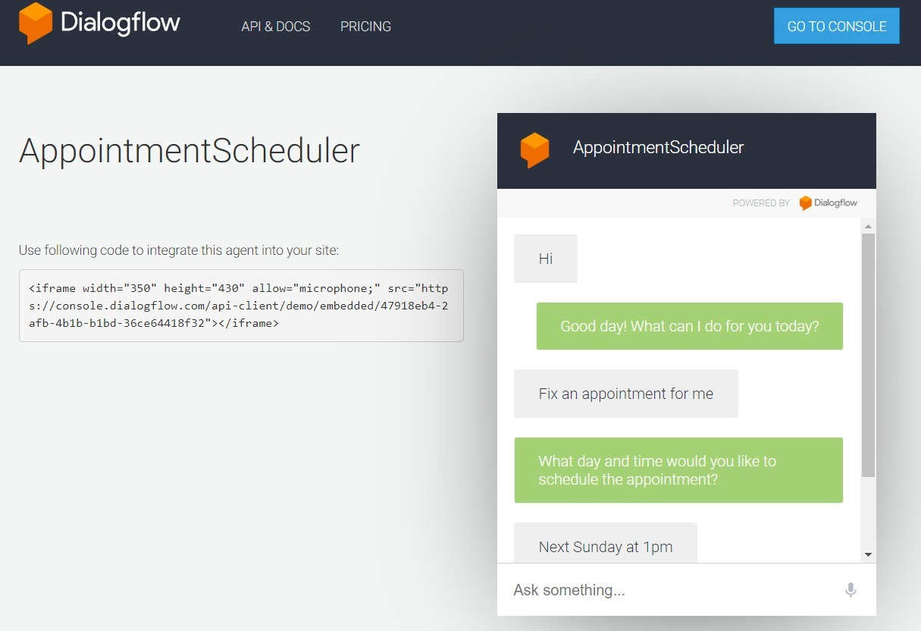

**Conclusion**:

Thus we studied an overview of how to build a Cognitive text-based application, Chatbot to understand context for a customer service application.